RHOMINDS / RHOQUESTIONNAIRE
RhoQuestionnaire
User Guide
Create, deliver, and understand repeatable questionnaires across every audience.
For company administrators, questionnaire teams, analysts, and recipients
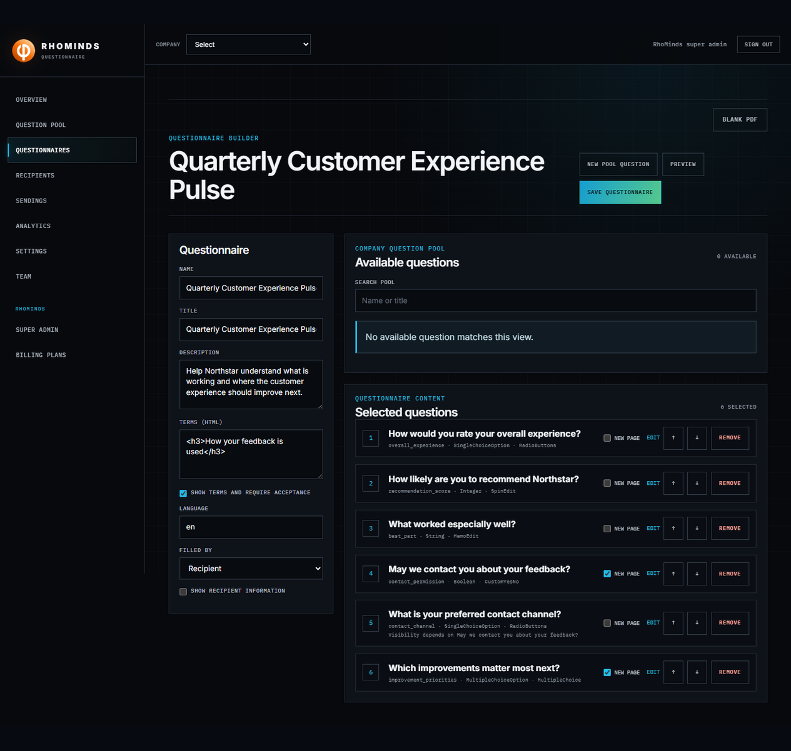
Cover visual — Predict-style questionnaire composition from the private company pool.
VERSION  1.0 | PUBLISHED  27 JULY 2026 | OWNER  RHOMINDS

HOW TO USE THIS DOCUMENT

Guide map
This guide follows the operational path from setup to analysis. Read it in order for a first launch, or jump to the task you need.
# | Section | Use it when
01 | Understand the service | You need the two-front model, roles, or terminology.
02 | Configure a company | You are setting access, identity, branding, email, or billing.
03 | Build questionnaires | You are creating private pooled questions or composing one of several questionnaires.
04 | Prepare recipients | You are importing people or organizing audiences.
05 | Create a sending | You are scheduling or repeating a questionnaire campaign.
06 | Complete a questionnaire | You are a recipient opening, saving, reviewing, or submitting.
07 | Read analytics | You need fair denominators, exports, or response reopening.
08 | Operate safely | You need reminders, status controls, roles, or troubleshooting.

Scope note The screenshots use a synthetic Northstar tenant and example.com addresses. They demonstrate the real local application without sending email or charging Stripe.

01 · ORIENTATION

Understand the service
RhoQuestionnaire is a multi-tenant service: every company gets its own branded workspace, users, recipients, questionnaires, sendings, settings, subscription, and results. A questionnaire can be reused across many sendings, and one recipient can receive many questionnaires.

Two focused fronts
Front | Who uses it | What it controls
Administration | Tenant owners, questionnaire managers, recipient managers, analysts, viewers, and RhoMinds super admins | Private question pool, multiple questionnaires, recipients, audiences, sendings, analytics, branding, email, billing, and team roles
Recipient | Invited customers or account holders | Opening assigned questionnaires, autosaving progress, reviewing answers, and submitting

Role guide
Role | Typical responsibilities
Tenant owner | Full tenant administration, settings, billing, email, team, content, and results.
Questionnaire manager | Private question-pool management, multi-questionnaire composition, preview, sendings, reminders, exports, and identified response reopening.
Recipient manager | Recipient records, categories, lists, custom fields, and imports.
Analyst | Question-level analytics and controlled result exports.
Viewer | Read-only analytics and results where allowed.
RhoMinds super admin | Tenant approval, fallback email, plans, manual subscriptions, and temporary audited bypass.

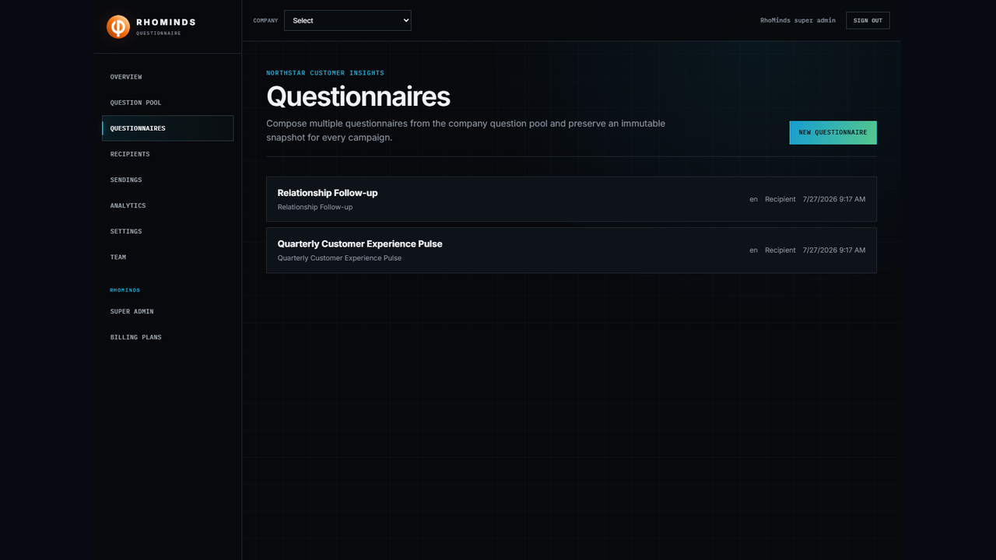
Figure 1. A company can own several questionnaires composed from the same private question pool.
02 · TENANT SETUP

Configure a company
Tenant settings are the source for company identity and defaults. Access and response-identity choices are copied into each new sending, so changing the tenant later does not rewrite historical campaigns.

Choose the recipient access mode
Setting | Use when | Recipient experience
EmailPassword | The company wants reusable recipient accounts and an inbox of assigned questionnaires. | The emailed link opens the sending; if needed, the recipient signs in on the tenant page.
InvitationCode | The company wants link-led access without a reusable password account. | The full emailed link is sufficient. The six-character code is only for a link that cannot be opened and must be typed.

Choose response identity
Mode | What administrators see | Operational consequence
Identified | Responses remain linked to recipients. | Authorized managers can reopen a submitted response; every reopen is audited.
Anonymous | Results are analyzed without recipient identity. | Question analytics stay suppressed until at least five responses are submitted.

Set branding, email, and subscription
- Open Settings from the tenant navigation.
- Confirm company name, legal name, slug, time zone, recipient access, and response identity.
- Set the logo URL, primary and accent colors, support details, website, and footer text.
- Configure either SMTP or Microsoft Azure email — never both. If the tenant has no provider, the RhoMinds fallback provider is used.
- Confirm the subscription allowance. Limits apply to recipients per sending and first-dispatch sendings per billing period; either limit can be Unlimited.
- Customize language-specific invitation, reminder, and password templates. The service sanitizes the body and wraps it in the tenant-branded RhoMinds frame.
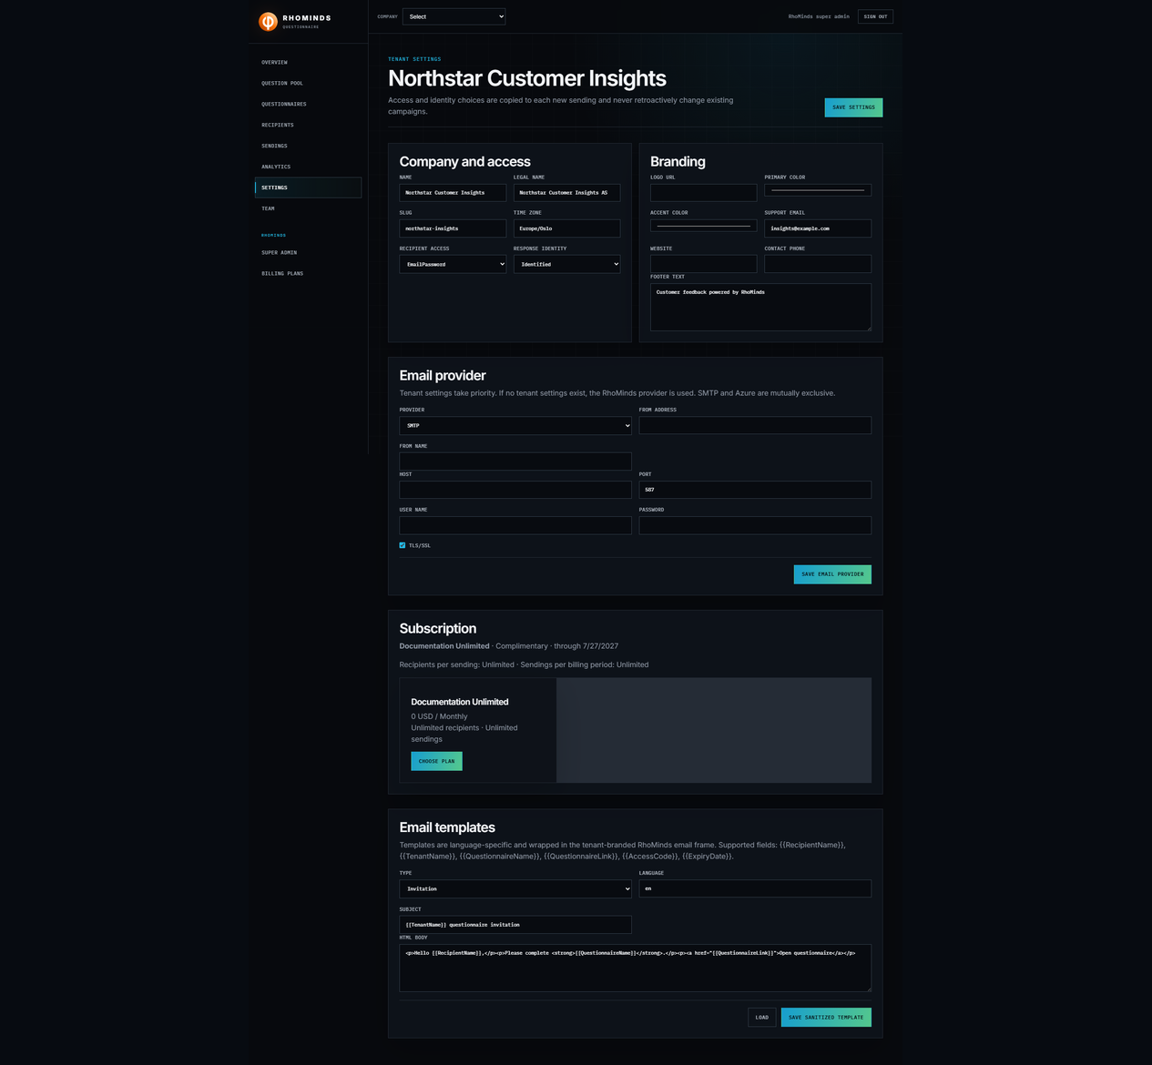
Figure 2. Tenant identity, access mode, branding, and the mutually exclusive email provider are managed together.
Provider precedence A complete tenant provider always wins. The RhoMinds provider acts only when the tenant has no provider. SMTP uses the shared RhoSMTP path; Azure uses the shared Azure handling path.

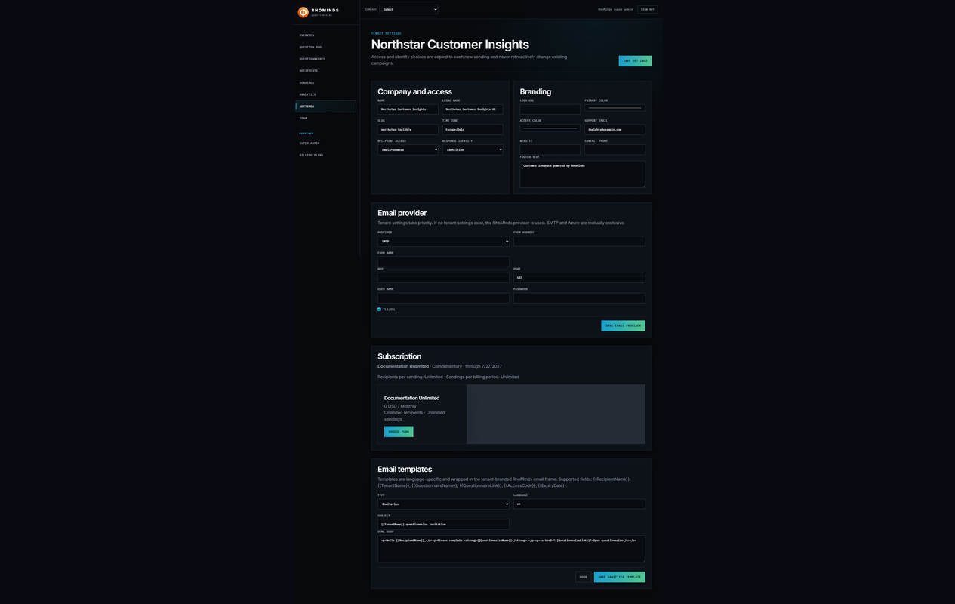
Figure 3. Subscription allowances and branded email templates are visible in the tenant workspace.
03 · QUESTIONNAIRE DESIGN

Build questionnaires from the company question pool
The Predict approach separates the company’s private reusable question pool from questionnaire composition. One company can create many questionnaires from the same pool, while preview uses the same shared runner as recipients and never saves or submits values.
Questions created here are private to the company. Editing a pooled question updates every draft questionnaire that uses it; questionnaires belonging to another company can never see or select it.

Questionnaire-level settings
Field | Purpose
Name | Administrative identity; unique inside the tenant.
Title and description | Recipient-facing heading and introduction.
Terms HTML / Show terms | Optional final-page terms plus required acceptance.
Language | Questionnaire language code and email-template selection context.
Filled by | Recipient, tenant staff, or either.
Show recipient information | Adds first name, last name, personal identifier, and gender fields to page one.

Supported question choices
Answer types | Controls and behavior
Integer, Decimal | Number input; integer answers also retain an integer value. SpinEdit is available.
Boolean | Yes/No controls including the custom Yes/No presentation.
String | TextBox or MemoEdit for short and long text.
DateTime | Date input.
SingleChoiceOption | SingleChoice, RadioButtons, or ListBox with stored/display option pairs.
MultipleChoiceOption | MultipleChoice with any number of selected options.

Build the definition
- Open Question pool and create each reusable question with its stable internal name, recipient-facing title, answer type, and control type.
- Define choice options, hierarchy, required state, visibility, enabled-state dependencies, masks, hints, descriptions, and picture URLs on the pooled question.
- Create or open a questionnaire and complete its questionnaire-level fields.
- Move questions from Available questions into Selected questions. The same pooled question may be selected into several questionnaires for this company.
- Order the selected questions and set questionnaire-specific New page markers. Parent and dependency questions are included with the question so the composition remains valid.
- Use Edit from the composer to change a pooled definition. The change appears in every draft questionnaire using it, but never alters an existing sending snapshot.
- Preview the complete questionnaire, test every page and dependency, then save.
- Create additional questionnaires from the same company pool whenever a different survey composition is needed.
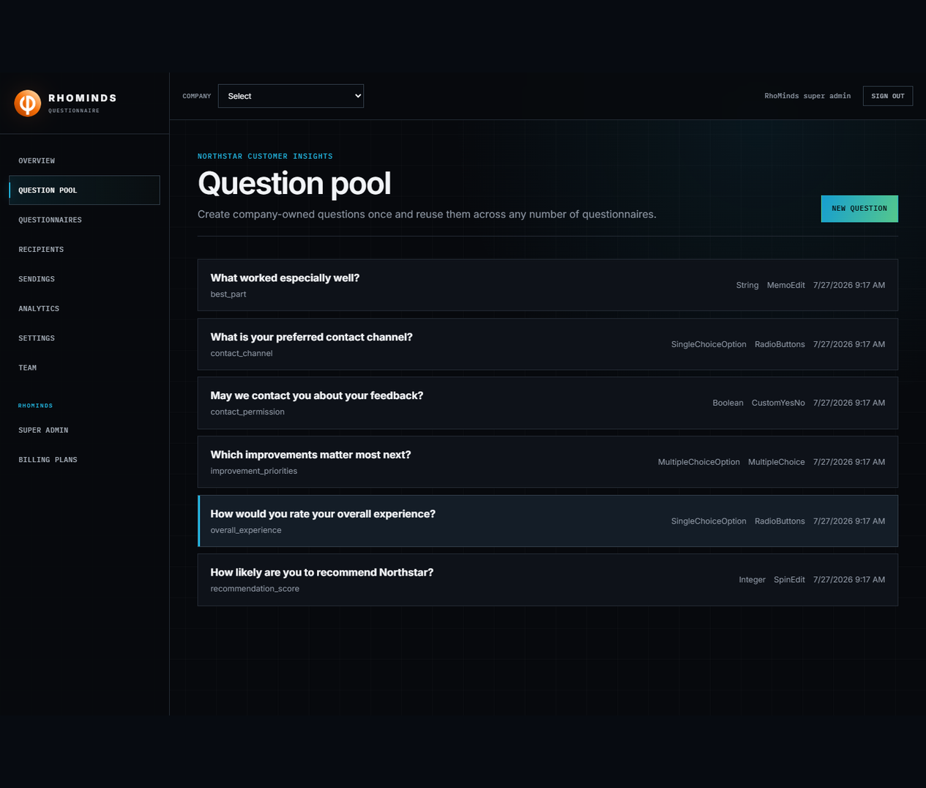
Figure 4. The private company question pool preserves every Predict-compatible question definition and option.
Figure 5. Questionnaire composition owns selection, order, and page breaks without copying pooled definitions.
No versioning in v1 The questionnaire itself has no separate version history. Historical correctness comes from the immutable definition snapshot stored with every sending.

04 · RECIPIENT MANAGEMENT

Prepare recipients and audiences
Recipients can belong to many categories and many mailing lists. Typed custom fields support richer filters without turning the core recipient record into a tenant-specific schema.

Maintain recipient records
- Add an email, name, optional personal identifier, gender, language, and (for account mode) a temporary password.
- Assign any number of categories such as region, segment, or advisory group.
- Create reusable mailing lists and choose their members.
- Define Text, Number, Date, IntegerBoolean, or FixedChoice custom fields.
- Deleting a recipient anonymizes the profile, removes active audience links and invitations, and detaches submitted responses from the person.
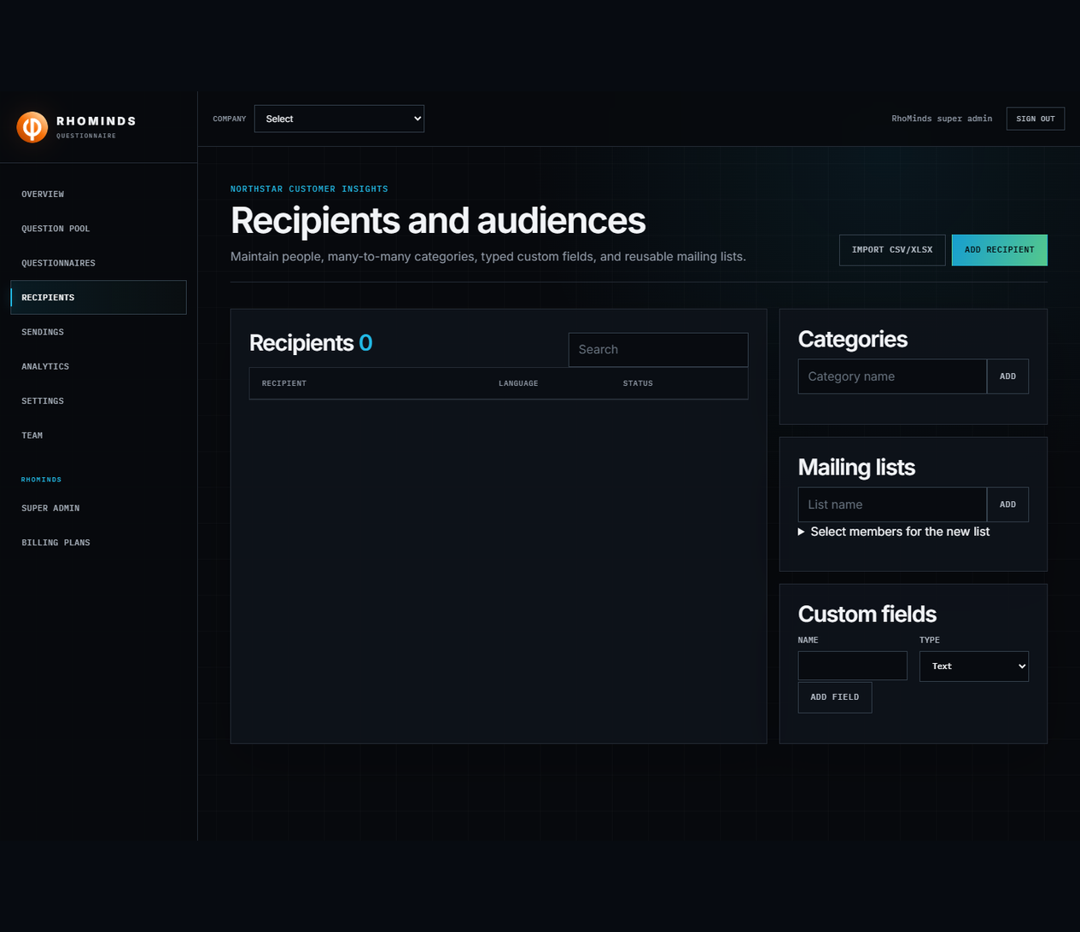
Figure 6. Recipients, categories, mailing lists, and typed custom-field definitions share one audience workspace.

Import CSV or XLSX
- Select Import CSV/XLSX and upload a file up to the configured limit.
- Review row count, duplicate-email count, sample rows, and reported errors. Preview does not import anything.
- Map every source header to a standard field, a custom field, or Ignore.
- Choose duplicate handling: Skip, Update, or Reject.
- Run the import and verify inserted, updated, skipped, and error counts.
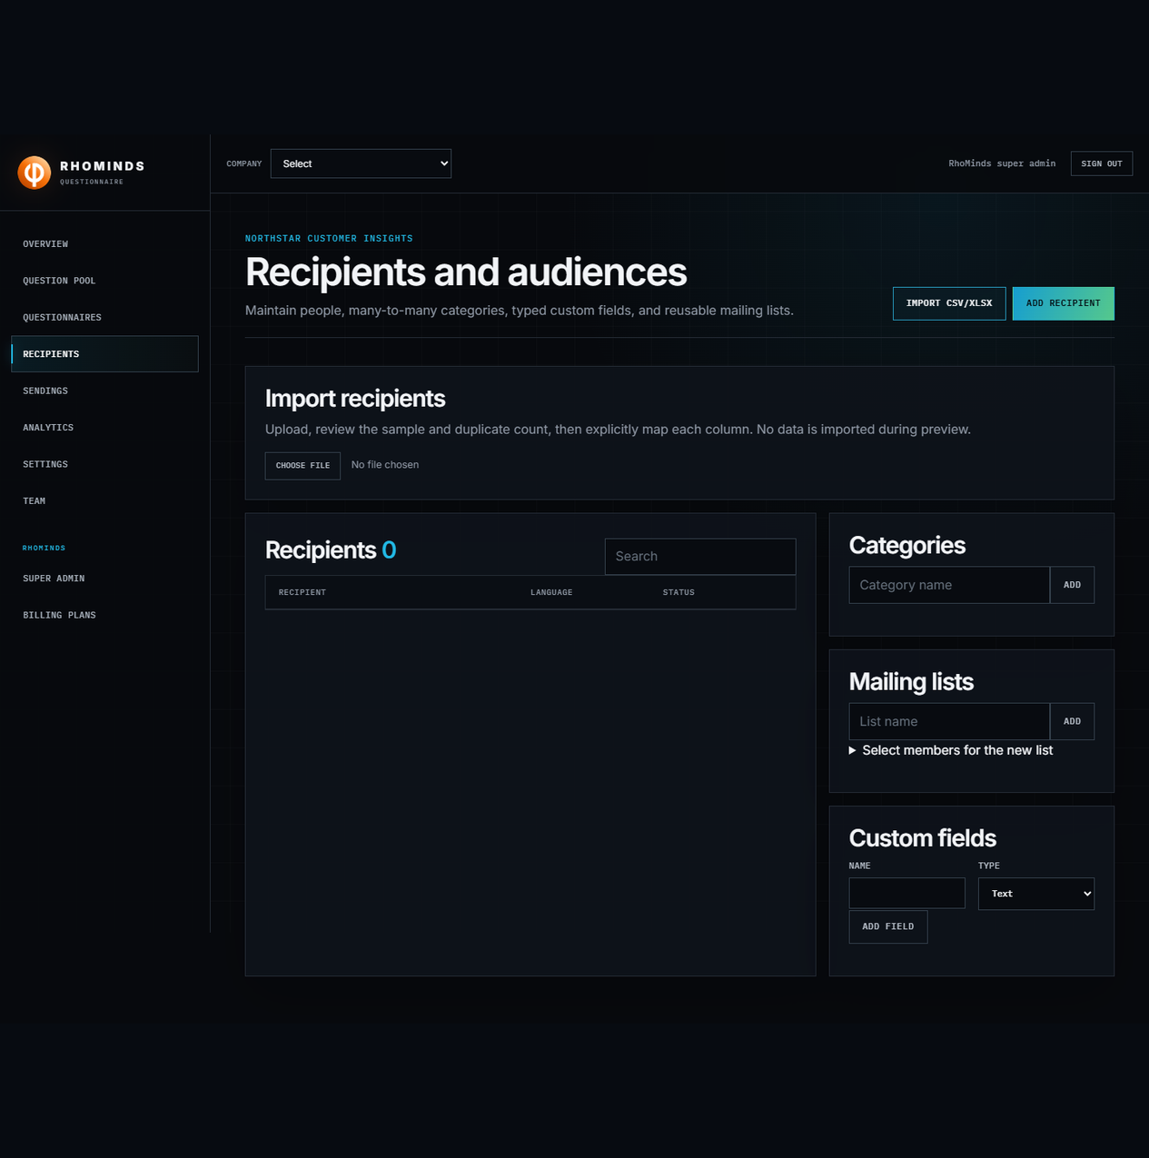
Figure 7. Import is a two-step preview-and-map flow; data is not written during preview.
05 · DELIVERY

Create and operate sendings
A sending is the repeatable campaign unit. It binds a questionnaire snapshot, audience, access mode, identity mode, schedule, expiry, delivery state, reminders, and responses.
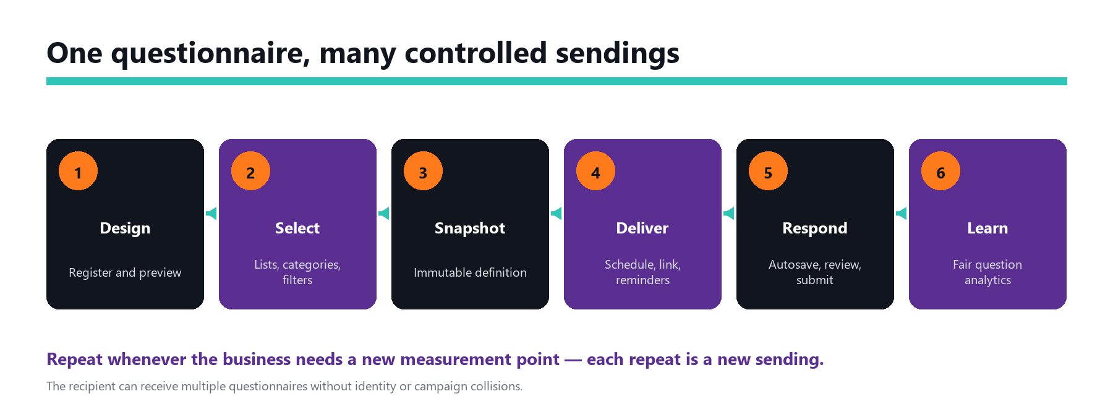
Figure 8. End-to-end questionnaire sending lifecycle.

Build the audience
- Select mailing lists, individual recipients, or both.
- Select categories and choose Match any or Match all.
- Add custom-field filters; every filter row must match.
- Preview the audience count before creating the sending.

Create, schedule, and repeat
- Enter a sending name and select the questionnaire.
- Optionally set schedule and expiry in UTC.
- Choose the audience and preview its count.
- Create the sending. The definition snapshot is now immutable for that campaign.
- Dispatch now or allow the scheduled worker to activate it.
- Use Remind incomplete for eligible recipients; the service enforces at most three reminders per recipient.
- Pause, resume, cancel, or close as operations require.
- For the next measurement point, create a new sending from the same questionnaire. The sending limit counts first dispatches, not questionnaire definitions.
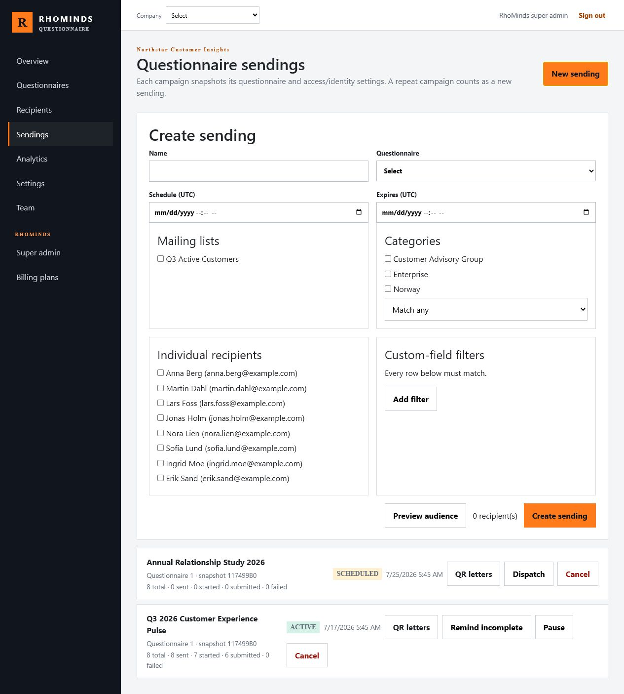
Figure 9. A new sending combines questionnaire, schedule, reusable audiences, direct recipients, and typed filters.

Sending states
State | Meaning and next actions
Draft | Created but not dispatched; can be dispatched or cancelled.
Scheduled | Waiting for ScheduledUtc; can still be dispatched manually or cancelled.
Dispatching | Delivery is being queued.
Active | Recipients can respond; reminders, pause, or cancel are available.
Paused | Temporarily stopped; resume or cancel.
Cancelled | No further operation; active invitation access is revoked.
Closed | Completed operationally; preserved for results and audit history.

06 · COMPLETE THE QUESTIONNAIRE

Recipient experience
The emailed full link already contains the tenant, sending, recipient, questionnaire, and recognition context. Clicking it is enough. A six-character code is needed only when a recipient must type access manually.

Open and continue
- In invitation-code mode, the full link opens the assigned questionnaire directly.
- In email-password mode, the link opens the assignment and requests sign-in only when the recipient session is missing.
- The tenant page lists active assignments for recipient accounts.
- Answers autosave as controls change and again when the recipient advances pages.
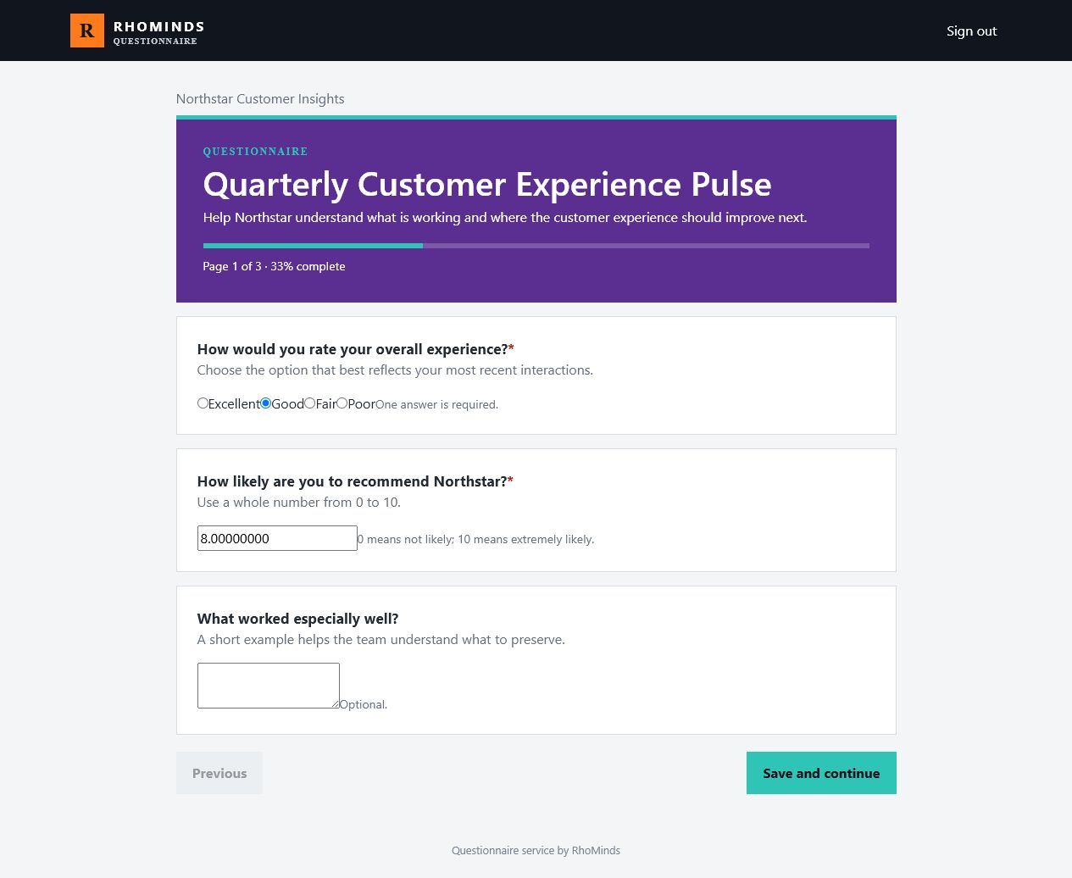
Figure 10. The recipient sees tenant branding, progress, required indicators, hints, and the shared runner controls.

Conditional questions and review
Visibility and enabled-state rules are evaluated from the answers already saved in the response. Hidden questions are explicitly recorded as hidden at submission, so analytics do not misclassify them as unanswered.
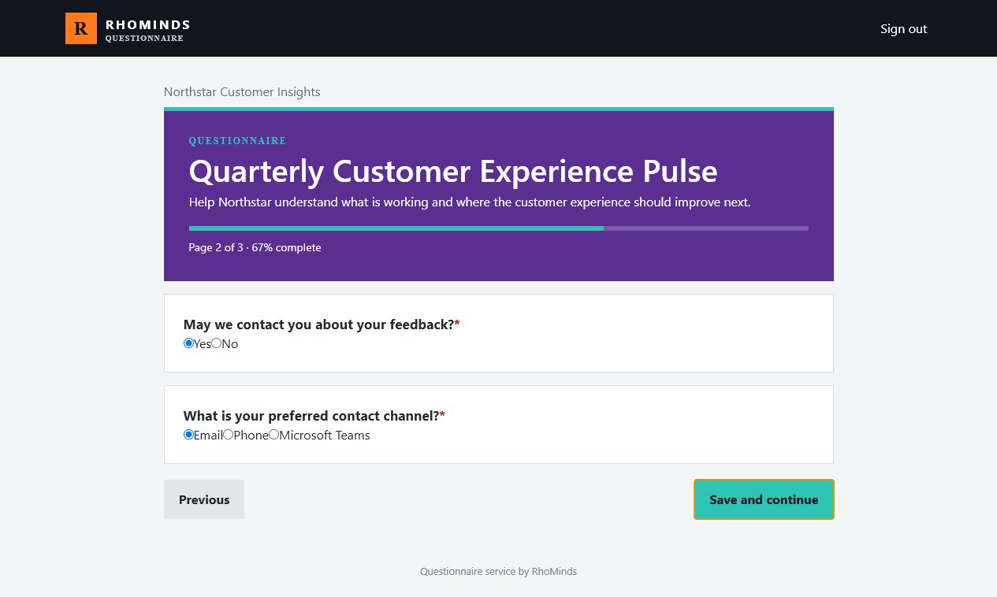
Figure 11. Page two reveals the preferred-contact follow-up because the recipient answered Yes.
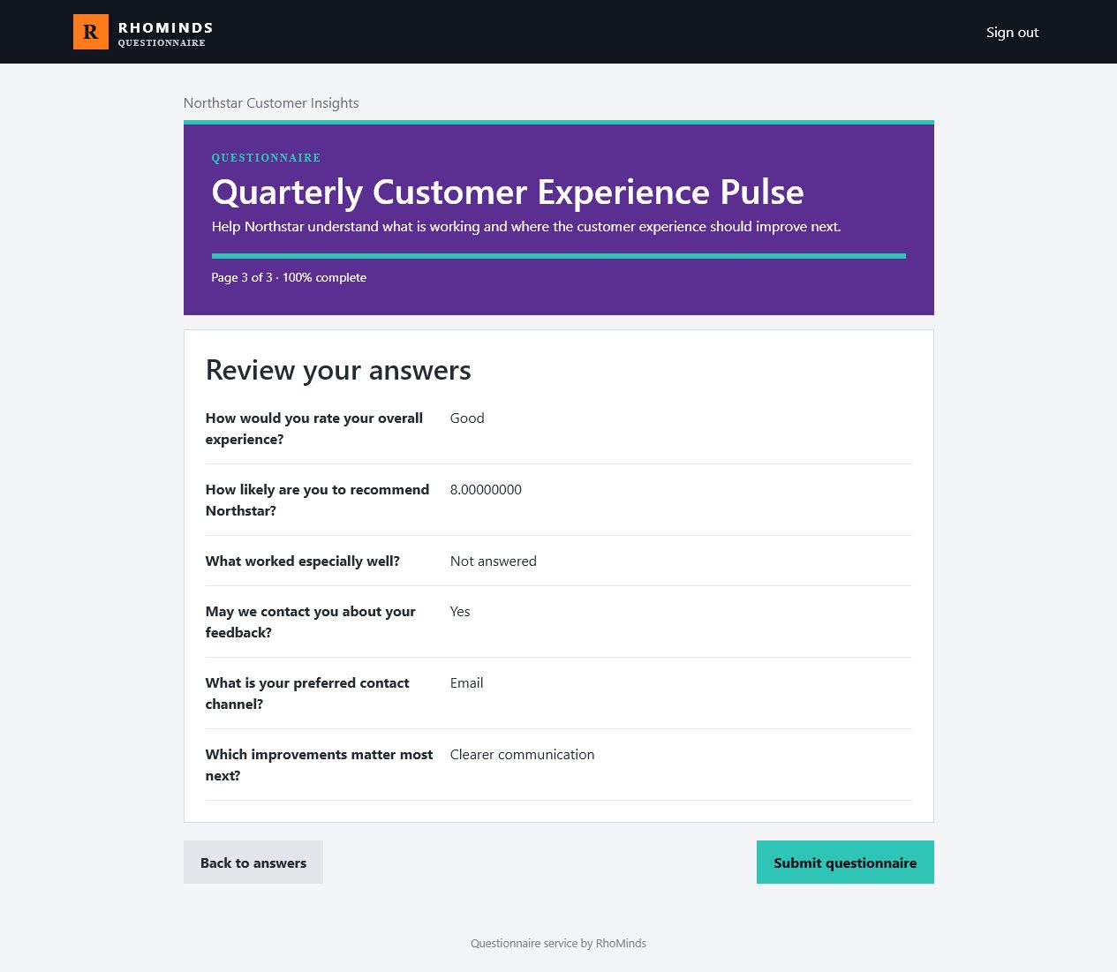
Figure 12. Review gives the recipient one final, complete summary before submission locks the response.
Submission is final After submission, the response is locked. Only an authorized manager can reopen an identified response, and that action is written to the audit log.

07 · RESULTS

Read fair analytics
Analytics are calculated per question from submitted responses and the sending snapshot — not from the questionnaire as it looks today.

Four denominators to read first
Metric | Definition
Eligible | Submitted responses minus responses where the question was hidden.
Answered | Eligible responses containing a value.
Unanswered | Eligible responses without a value.
Hidden | Submitted responses where dependency rules hid the question.

Per-question summaries
- Choice questions show respondent counts and percentages per option.
- Numeric questions show mean, median, minimum–maximum, and first–third quartiles.
- Anonymous sendings remain suppressed below five submitted responses.
- Identified sendings show response owners and allow authorized reopening.
- CSV, filled-response PDF, blank questionnaire PDF, and QR invitation-letter PDF exports honor role checks.
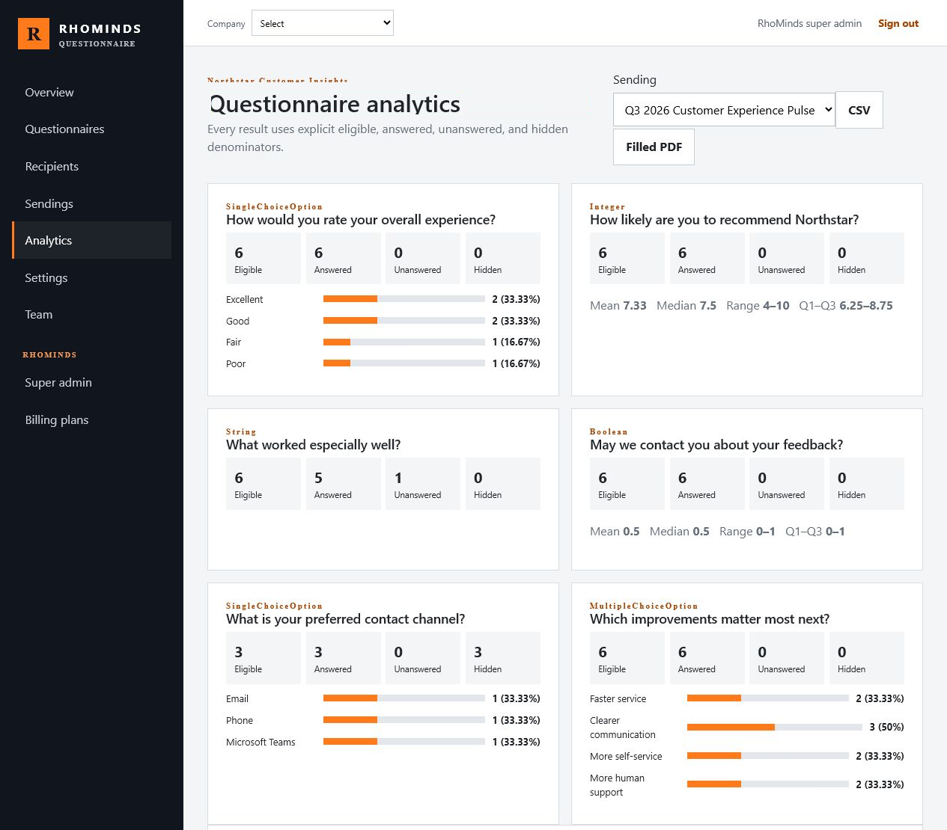
Figure 13. Question-level cards expose eligible, answered, unanswered, and hidden counts before any summary statistic.
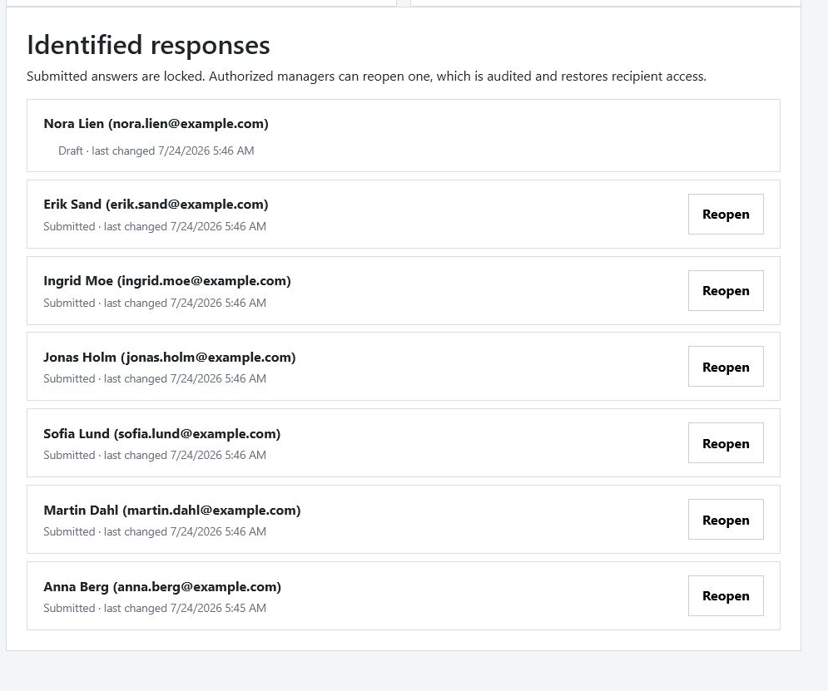
Figure 14. Identified responses show status and offer an audited Reopen action to authorized managers.
08 · ADMINISTRATION AND TROUBLESHOOTING

Operate safely

RhoMinds administration
- Create and approve tenants, register the first owner, and manage the RhoMinds fallback email provider.
- Create Stripe plans with recipient and sending limits, including Unlimited for either dimension.
- Apply audited complimentary or manual subscription overrides when authorized.
- The temporary RhoMinds superuser bypass works across every tenant and recipient login and records every use. It is an interim release behavior, not the intended production end state.
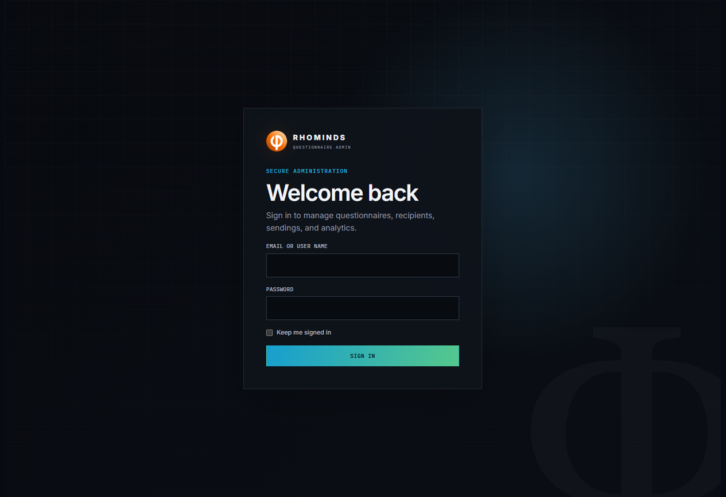
Figure 15. Administration sign-in uses the official RhoMinds mark and contains no transient security banner.
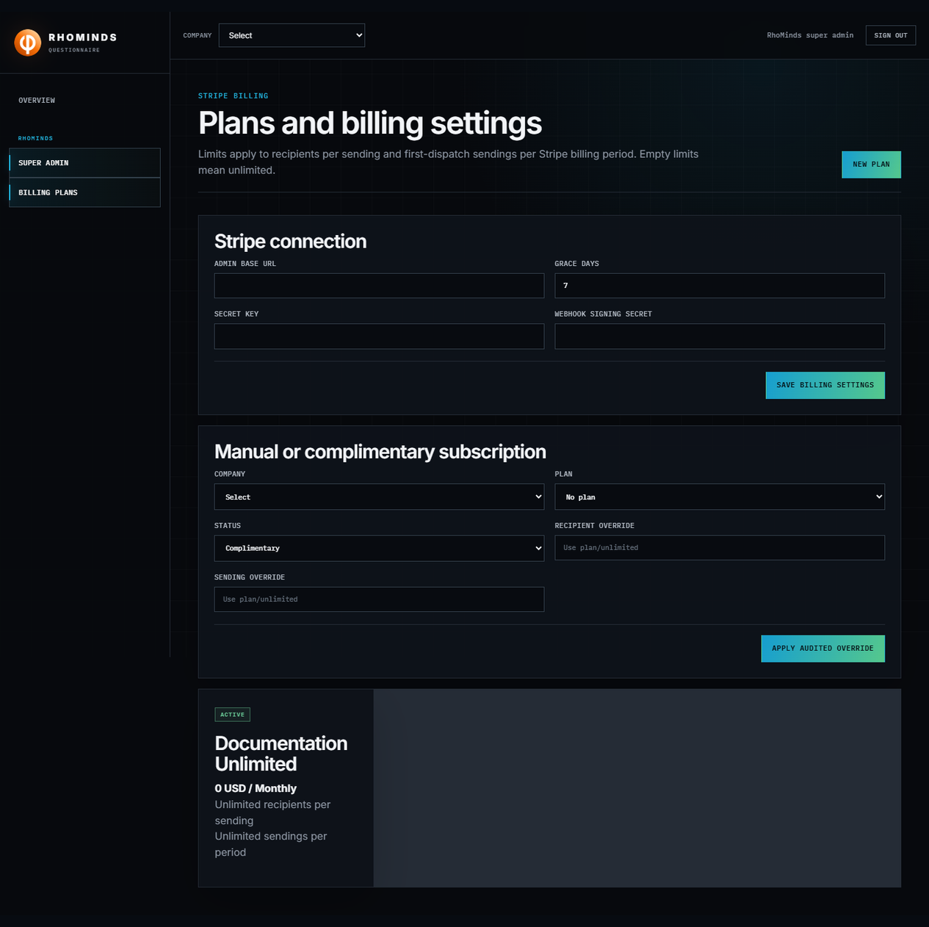
Figure 16. Billing plans and manual subscriptions use the same two limit dimensions as sending enforcement.

Troubleshooting quick reference
Symptom | Check first | Resolution
Recipient cannot open a link | Tenant/sending/recipient/questionnaire IDs, expiry, sending state, access mode | Resend the original full link, restore the sending if appropriate, or sign in for account mode.
Six-character code fails | Characters, case, expiry, and the exact sending | Normalize spaces/dashes, then issue a new sending or invitation when expired. Codes do not transfer between sendings.
Question is missing | Visible-when rule and source answer | Preview the dependency and expected JSON values; hidden is intentional when the rule does not match.
Cannot create or dispatch | Subscription status and both limits | Choose a valid plan or ask RhoMinds for an authorized audited override.
No email leaves the queue | Tenant provider, then RhoMinds fallback | Configure exactly one complete SMTP or Azure provider. Do not configure both.
Anonymous analytics are blank | Submitted response count | Wait until at least five anonymous responses have been submitted.
Submitted response needs correction | Identity mode and user role | An authorized manager may reopen identified responses only; the action is audited.

Safe operating rule Never test with real delivery credentials or chargeable Stripe settings in a local documentation environment. Health checks, preview, and synthetic data are sufficient for a workflow demonstration.

